Occupational Health Service

Health Surveillance
Portal
Guidance

Introduction

Over the page are the instructions you will
need to follow to access the health surveillance questionnaire.

Both the employee and their manager should complete the questionnaire prior to the health surveillance appointment. The questionnaires can be accessed on computers, laptops and smart phones.

If you haven’t already done so you will need to begin by creating an account on the County Council Occupational Health system – steps 1 -5.

If you are a manager then you will need to complete the “Health Surveillance – to be completed by manager” Questionnaire for the person you have received an email about – Steps 6 - 9.

If you are the employee then you should complete the “Health Surveillance – to be completed by employee” questionnaire – Steps 6 - 9.

The Occupational Health nurses will then check your questionnaire prior to your health surveillance appointment.

Getting Started
1 | https://GenohsisPortal.cumbria.gov.uk/Portal | You should access the system using the link
2 | 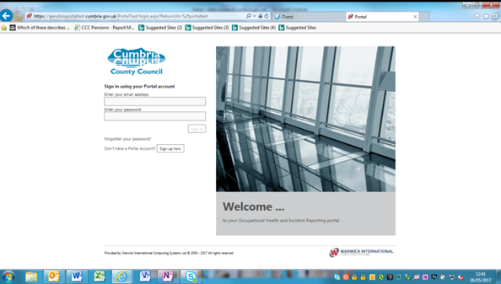 | You will need to “Sign up” to the system by clicking on the button shown  .
3 |  | Complete the boxes  The company reference is M500FAB8  The password should contain – upper and lower case, numbers and symbols.  If this is the first time you log in you will receive a verification email from the system. You will need to go to that email and following the instructions.  Enter your personal details  Click on next
4 |  | Enter your personal details  Click on next  Enter your contact details  Please DO NOT complete the employment details.  Please click on Save Changes
5 |  | If at any time the expected pick list seems to move or not be in the correct place then you please change your zoom to between 100 and 125%. This should correct the problem.  Quick Guides – you can exit the quick guides by click on the “Exit quick guides” button. If you cannot see the blue bar again your zoom may have affected what you can see. Please change it to between 100 and 125%
6 |  | Create a new medical referral  To create a new medical referral form click on the drop down arrow.  Choose “My Forms”  The other items in this list are concerned with the Safety side of the system and can be ignored.
.Creating a Health Surveillance Questionnaire
7 |  | To create a new form  Click on “Create New Online form”
8 | 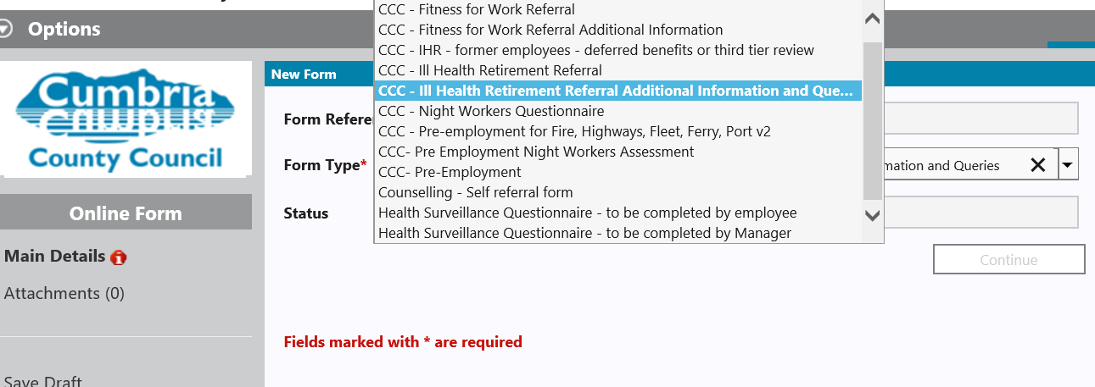 | Click on the drop down list in form type.  If you are the employee choose “Health surveillance – to be completed by employee” form.  If you are the manager choose  “Health Surveillance – to be completed by manager”  Click on continue and complete the rest of the questionnaire.  You can “Save Draft” at any point
9 |  | Once you have finished completing the form please ensure you click on the submit button
Your form will then be sent to the Occupational Health Service.

If you have any difficulties please call the Occupational Health Service on 01768 812556.

