Coping with Trauma

You may find this leaflet helpful if you have been involved in, or affected by, a traumatic incident
It provides information on how you may expect
to feel in the days and months ahead and to help you understand and have more control over your experience.
We will all react differently and what is distressing for one person may not be for someone else; but it is important to acknowledge how you are feeling,
to accept that it is okay to feel like this and know that it will pass.
The emotional and physical reactions that follow traumatic events are usually intense, they often confuse, frighten and shock. You may also be surprised by reactions that are unfamiliar and seemingly out of character for yourself or others.

“An abnormal reaction to an abnormal situation is normal behaviour”
Viktor Frankl

How you may be affected
The reactions below are all entirely normal and should fade fairly quickly as other events take place.
• Flashbacks, Repeated, intrusive recollections
of events, Dreams about the event
• Numbness
• Sadness
• Not wanting to be reminded of the event
• Loss of enthusiasm
• Fatigue, Tiredness and Restlessness
• Emotional withdrawal
• Changes to your outlook on life
• Anger
• Fear

What you can do to help yourself
Trying some of the following hints may help to alleviate the emotional strain associated with the event
Do:
• Take time out to get sufficient sleep (your
normal amount), rest and relax, and eat regularly and healthily
• Express your feelings as they arise
• Tell people what you need. Talk to people
you trust. You don’t have to tell everyone everything, but telling nobody anything is often unhelpful for you.
• Take care at home or when driving or riding – accidents are more common after a traumatic or stressful event.
• Try to reduce outside demands on you and don’t take on extra responsibilities for the time
being.

Don’t
• Bottle up these feelings. Think whether it
would be helpful to talk about them with somebody you trust.
• Get embarrassed by your feelings and thoughts, or those of others. They are normal
reactions to a very stressful event.
• Avoid people you trust.
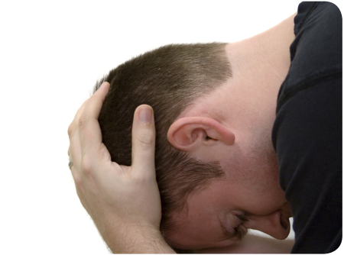

When to ask for help
You might need help if you have been experiencing any of the following reactions for several weeks
and there is no sign of them getting better.
• You want to talk about what happened and feel
you don’t have anyone to share your feelings with.
• You find that you are easily startled and
agitated.
• You experience vivid images of what you saw
and have intense emotional reactions to them.
• You have disturbed sleep, disturbing thoughts
preventing you sleeping or dreams and nightmares.
• You are experiencing overwhelming emotions that you feel unable to cope with or experience
changes in mood for no obvious reason.
• You experience tiredness, loss of memory,
palpitations (rapid heartbeat), dizziness, shaking, aching muscles, nausea and
diarrhoea, loss of concentration, breathing difficulties or a choking feeling in your throat
and chest.
• You feel emotionally numb.
• Your relationships are suffering.
• You are worried about your alcohol or drug use
since the incident.
• Your performance at work has suffered.
• Someone who you are close to tells you they
are concerned about you.
Where to find professional help
If you continue to experience, or recognise in anyone you work with, the reactions described in this leaflet, professional advice and support can be obtained from the following.
• Contact your GP or call the NHS 111 helpline
• Submit a self-referral for councelling or call Occupational health on 01768 812556
• Call Mindline on 0300 561 0000
• The Samaritans are available 24/7 on 116 123

